Leigh Stubbs
20 Bentwell Avenue
Arnold
Nottingham
NG5 7EZ
07813 439085

To: Residents and Business Owners: Newstead Abbey Grounds

Date: 25th April 2023
ADVANCE NOTIFICATION: Newstead Abbey Dash: Friday 28th July 2023

Dear Residents and Business Owners,
This letter is to advise that the annual Newstead Abbey Dash 5k race will be taking place again this year on Friday 28th July 2023, held once again within the grounds of Newstead Abbey.
This annual race is organised by the Redhill Road Runners running club and the Newstead Abbey Dash has been approved and a licence for the event has been granted by UK Athletics Rules for Competition (licence number 2023-45392).
Whilst we are taking all reasonable steps possible, there may be some minor inconvenience to residents and business owners throughout the duration of the event.
We will have marshals supporting throughout the evening, who will be on site from 17:30 to manage parking, directing visitors & spectators and to ensure the safety and wellbeing of participants and residents throughout the evening.
Marshals will also be placed along the route but do please be aware that from 18:50, there will be large numbers of runners on the main road through Newstead Abbey (from the entrance on the A60 Mansfield Road), through to Station Avenue. For your information, there is a map of the course route which has been included in this letter along with our Frequently Asked Questions.
You can find additional information on our website but if there are any further queries then please contact me.

Yours Sincerely,

Leigh Stubbs
Chairman - Redhill Road Runners

Newstead Abbey Dash: Frequently Asked Questions
Q: Who are Redhill Road Runners?
We are a running club based in Redhill, Arnold for adults of all ages and abilities. We hold club runs every Monday and Wednesday night at 18:00 and meet in the Young People’s Centre at Redhill Leisure Centre. You can find out more about us on our club website or via our Facebook page.

Q: Do you have a licence for the Newstead Abbey Dash?
A: The Newstead Abbey Dash has been approved by UK Athletics Rules for Competition and a licence for the event has been granted for the race (licence number 2023-45392).

Q: What is the route for this race?
A: The 5k course itself starts on the main drive, with a 1km descent to the abbey and lake. Runners will then head up through the shade towards Newstead Village, before reaching a turning point where runners will then come back again down that road. The finish point is at side on the green in front of Newstead Abbey itself.

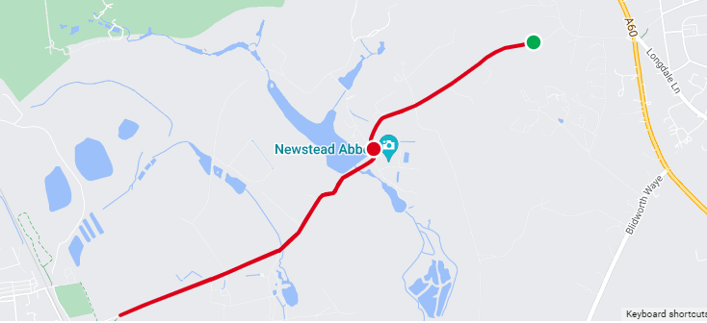

Q: How can I participate in the Newstead Abbey Dash race?
A: Entries for the race can be made online via www.runbritain.com. Just search for Newstead Abbey Dash 5k. Entries close at midday on race day. Please note that it is not possible to enter on the day.

Q: Is this event chip timed?
A: Yes, this event is chip timed and accurately measured.

Q: What is the minimum age to enter this event?
A: 11 years old for a 5k, as per England Athletics rules.

Q: If I can't make the event, can I have a refund?
A: Sorry, we are unable to offer refunds. However, you can transfer your race number.

Q: Can I transfer my race entry to someone else?
A: Yes, you have until midnight on Sunday 23rd July 2023 to transfer your race number. Please visit https://www.redhillroadrunners.com/our-races for more information. Please note that we are unable to complete transfers after this date.

Q: When will I receive more information about the event?
You will receive all race information via email in the week leading up to the event - information will be sent to the email address supplied when you enter the race. You can also find information on our website www.redhillroadrunners.com/our-races, or on the Redhill Road Runners Facebook page.

Q: Do we collect our Timing Chip and Race Number on the day of the event?
A: Yes, that is correct. Please make sure you arrive at least 45 minutes before the race start so you have plenty of time to collect them and get to the start point for the race.

Q: Are there water stations?
A: There are no water stations on the course, but there will be a water station at the finish point at the end of the race. New for 2023: The Newstead Abbey café will also be open from 18:00 on race day where you can purchase food and hot and cold drinks. Note that the café is cash only so does not accept card or contactless payments

Q: Do you have a baggage drop? Do you charge for it?
A: Runners are encouraged to leave bags and personal items securely locked in their cars. For any runners arriving by foot or bike, we have a small baggage tent where you can leave items. Please note that the baggage storage is provided free of charge out of goodwill for runners and items are left at your own risk. The race organisers do not accept any responsibility for damaged or lost items.

Q: What do I get at the end of the race?
To allow us to keep this race as cost efficient as possible for you, we do not give out medals or t-shirts at the end. However, you can help yourself to water and snacks when you finish the race.

Q: Where can I find my results after the event?
A: Results will be post on our website and Facebook as soon as possible after the race. Please visit https://www.redhillroadrunners.com/our-races for details.

Q: Am I allowed to wear headphones?
A: We strongly advise against it. To ensure the safety and wellbeing of others at these events, you need to be aware of your surroundings and be able to hear marshals’ instructions. See the event guide on our website for further information.

Q: Are your events official running events?
A: Our races are licensed by Run Britain (license number: 2023-45392). The courses have been officially measured by the Association of UK Course Measurers and a copy of the measurement certificate and race license will be on display at the information desk and on our website.

