2022

Redhill Road Runners
5/25/2022
Redhill Road Runners Annual General Meeting
Annual General Meeting

Contents
Attendance 2
Approval of previous AGM minutes 2
Matters arising from last year’s minutes 2
Chairman’s report – L. Stubbs 2
Treasurer’s report 3
Brief reports from officers 4
Coaches report - S. Nash 4
Men’s cross country report – P. McNally 4
Membership report – Mike McHardy 4
Social report – T. Harper 4
Kit report – W. Lawson 5
Communications report - K. Horton 5
Fell running – P. Henley 6
Summer league – C. Greyson 7
Election of Officers 8
Any other business 8

Attendance

Attendees present 25
Leigh Stubbs (Chair), Mark Davis, Graham Webster, Mike McHardy, Steve Lawson, Paul Newton, James Furness, Wendy Lawson, Simon Nash, Pete McNally, Clive Grayson, Steve Gibson, Charlotte Sykes, Rosemary Horne, Michael Horne, Phil James, Chris Ward, Darren Long, Nike Dixon, Kirsty Hill-Dixon, Des Gibbon, Wez Annison, Marie Copland, Susie Hennessy, Josh Davies
Apologies received from Pete Henley, Toni Harper, Kate Horton
This year’s AGM was held in person at the Waggon and Horses, Mansfield Road, Redhill Nottingham
Meeting Started at 20:07

Approval of previous AGM minutes
Approval of the previous minutes were approved by a show of hands

Matters arising from last year’s minutes
No matters raised

Chairman’s report – L. Stubbs

Thank you for all attending this evening. The AGM will be hold first and then followed by the club awards.
I’d like to start by thanking the committee and all the run leaders for their hard work and support over the last year or so. It’s been great to have the club back to normal and seeing everyone back training in groups and having a laugh.
We had one of our biggest turnouts for our C25K course to date. It was great for the club and look forward to seeing their progression over the next few months and years. I would like to think Wendy Lawson for all her hard work along with Darren Long and Peter Henley for supporting her.
I was going to talk about the running scene etc but will leave that to Clive and Pete for their reports
On the social side it’s been great to get out for events and have a laugh with everyone, thank you Toni for organising.

Treasurer’s report
accounts were approved by a show of hands
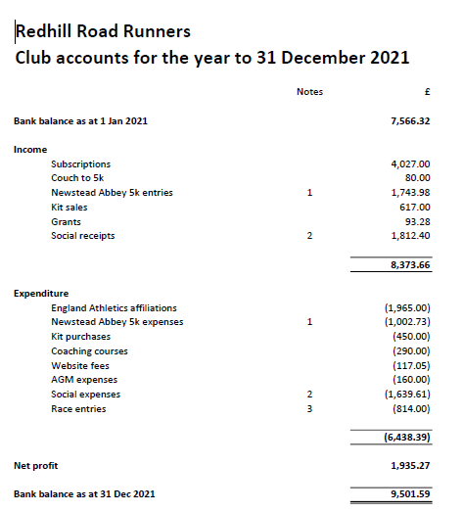
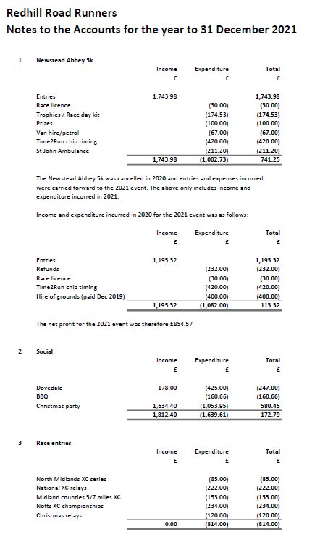

Brief reports from officers

Coaches report - S. Nash

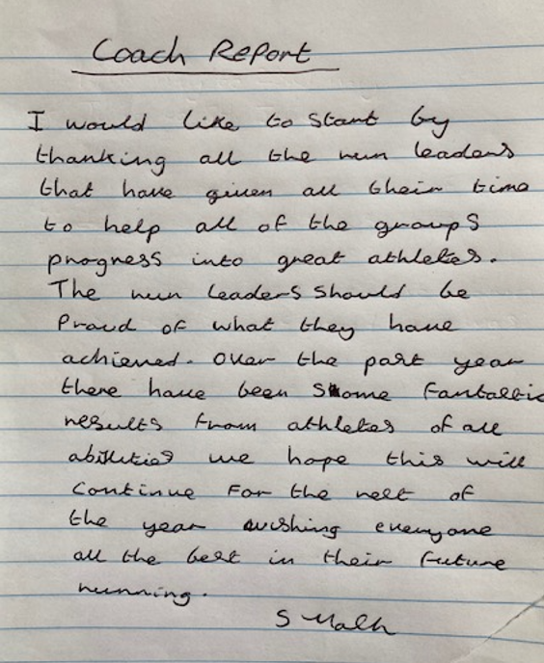

Men’s cross country report – P. McNally

Generally a successful cross country season for Redhill. Participation from the men's side of the club was good, the amount of women participating needs to be encouraged and increased.

The club participated in the North Midlands League that took place over 4 Saturday afternoons between October 2021 and January 2022. There were some notable indivdual success as follows;

Peter McNally MV55-59 Gold

Ray Poynter MV65-69 Silver

Michael Horn MV70+ Silver

Rosemary Horn FV65+ Gold

And the Male Masters won Team Bronze

Ray Poynter, Michael Horn, Marytn McHale, Pete McNally and Rosemary Horn completed all four races.

The club also participated in the East Midlands League which took place on a Sunday morning on 4 consecutive Sundays beginning at the end of January 2022. Generially participation in these events was higher for both men and women. Leigh Stubbs, Mark Davis, Ray Poynter, Michael Horn, Clive Hayward, Pete McNally and Rosemary Horn completed all 4 races. The men's masters team came second overall and our senior men's teams finished third.

Redhill put two men's teams in the British Master's Relay Championships at Long Eaton on Saturday 30th October 2021, one in the 55-64 age group and another in the 65+ age group, both teams did well.

The club also competed well in the National Cross Country Relays at Berry Hill park on the 6th November 2021 and were able to field 3 men's teams and 2 women's teams.

The club did well in the local Midland Counties 5/7 miles Championships at Bulwell on the 20th November 2021, the women's team led home by Lisa Doyle just missing out on a podium team finish and the men led home by Mark Davis with the team coming in 6th place.

The Nottinghamshire Cross Country Championships at Berry Hill Park in Mansfield on Saturday 8th January 2022 proved to be the best day of the season for Redhill, 22 men and 12 women represented the club with pride, on a cold, muddy, wet, difficult cross county course. Five individual medals were won and three team medals, the senior women winning bronze, the masters women winning bronze and the masters men winning silver. This day showed Redhill at their best as all present helped to create a really good team atmosphere, fully supporting all those who took part. There were no other clubs who could field 4 over 65 runners and one over 75 among their number, Redhill did.

The following indivduals won county medals;

Gold FV45-54 Carolyn Hay, Gold FV65-74 Barbara Stevens, Gold MV55-64 Peter McNally, Silver MV75+ Nigel Daniels and Bronze F65-74 Rosemary Horn.

The womens team were led home by Carolyn Hay in 9th place and she was selected to run for Nottinghshire on this performance, which for a vet45 is simply outstanding and the men's team were led home by Ian Hales in 30th place who was was beginning to put together some excellent cross country performances despite completing sub 20 minute park runs before his races.

The 29th of January 2022 seen a final return to Berry Hill Park for the Midlands Cross country Champs. In really windy conditions on a testing course. Barbara Stevens won the Midlands Masters gold for her age group and Carolyn Hay picked up silver in her age group. Pete McNally picked up bronze in his masters age group. Ray Poynter also picked up an age group bronze, despite falling over 3/4 times. Special mention to Ian Hales, Pete McNally, Wayne Scott, Ray Poynter, Tim Raynor and Steve Gelderd who ran the following day as well in the first East Midlands race at Holme Pierrepont.

The cross country season came to a close for most people on the 26th Feburary 2022 in London at Parliament Hill on an extremely muddy course. Pete McNally led home a men's team of 9, cheered on by non running support from Notthingham, Simon Nash, John Kelley and Charlotte Sykes. A mention to Paul Newton who rose from the physiotherapist's chair to run on one leg around the course, holding onto a shoe, which was thrown away on completion. A night out in London followed and poor Dave and Kathryn Walsh are now barred from their local after some Redhill antics.

The only Redhill member to compete in another race was Ray Poynter who ran in the British Masters Cross Country Champs in Tonbridge on the 12th March 2022, coming 12th in his age group.

Big thanks to 3 individuals especially who during the course of the season helped me to complete this role, Clive Greyson, Leigh Stubbs and Kate Horton. I would also like to note the assistance and support of Ray Poynter, Michael Horn and Rosemary Horn on race days with either bringing a tent or helping to set up and take down the club tent.

Membership report – Mike McHardy
England Athletics fee increased from £15 to £16, however the club maintained its costs of £32 for annual membership. Those joining from the Couch to 5k had reduced fees as they paid for course, and then opted to become full members
Membership for the year 2022/23 is up from 21/22.
21/22 was a total of 121 members. Currently we have 147 paid members. Increase of 21%.
Of these, we have 40 members who did not pay or were not involved in the club in 2021 who have either joined or returned for this year. Currently There are only 16 members who have not paid this year who we did have as members last year.
The male/female split is increased from 21/22 from at 76/45 (37% Female) to 84/63 (43% Female)

Social report – T. Harper
Apologies that I am unable to share my report with you in person.
It has been great to see our members, both old and new, come back together and bring back the community feel of past.
Following the last AGM in October, we kicked off social events with a successful outing to watch the Nottingham Panthers. Although we had to witness the Panthers lose, it was great to attend an event together without covid measures.
We were then fully into our Christmas events. We started with the return of our Christmas lights and headtorch run as well as the requested Secret Santa. Our Christmas events concluded with a fantastic club turn out of 60 people to the Christmas party at Bestwood Lodge. A wonderful covid-measure-free Christmas period!
Some suggestions were put forward for social events which led to a night out of bowling. The new facilities provided for another fab evening out.
Now to ensure you have the Redhill BBQ date in your diary (Saturday 9th July) and fingers crossed for some great weather!

Kit report – W. Lawson
Kit is selling well. We have just had a new order of club kit delivered and some of this has already sold. The email system for members placing orders works well.

Fell running – P. Henley
Thankfully 2022 has more or less seen a full return to running and indeed fell running.
So it was with great pleasure that I was once again able to put together RRR Fell GP.
2020 had seen the introduction of our first ultra in the series. Covid however put stop to this. So I was delighted to add Ranger Ultras PB55/18KM to our 2022 series.
We still have four more races left in the series too.
It has been an ongoing pleasure leading groups out on the fells as always. As well as RRR, I have also been leading runs for Social Trail Running Nottingham and FSTR. The addition of these groups is helping connect and grow our Trail and fell running community.
As always, I am keen to get more people out on the trails, and welcome any suggestions which would make them more welcoming to newcomers.

Summer league – C. Greyson
The Summer League is back!
After a 2 year hiatus owing to Covid, the Summer League made a welcome return on Wednesday the 20th April at Hexgreave Hall.
And what a tremendous turn-out from Redhill RR. 43 men and 23 women. It really was great to see that sea of red, white and grey at the start of the race.
Then we had Holme Pierrepont on the 11th May with 41 men and 23 women.
We are currently leading the veteran (Masters) Mens and Ladies teams which is excellent.
The remaining fixtures in the series are:-
• Wollaton Park 15 June
• Worksop 13 July
• Teversal 3 August.
Thank you to those who have helped with the results on the finish line – Wez Annison, Leigh Stubbs, Kate Horton and Paul Newton.
We also fielded a Mens team and a Ladies team in the 12-stage and the 6-stage road relays back in April. The first time we have fielded teams in these events for quite a few years and meant that I lost a bet with myself as I said I would buy all the men a drink if we actually managed to get 12 men to run.
Finally don’t forget the County Champs events remaining for this year:-
• 5K – Newstead Abbey – 29th July.
• 10K – Nottm Uni (organized by Formula One). – 19th August.

Election of Officers

Position | Name | Standing Y/N | Nominee | Proposed | Seconded
Leigh Stubbs | Chairman | Y
Kate Horton | secretary | N | Mark Davis – stand-in | Leigh Stubbs | Graham Webster
Mark Davis | Vice Chair | Y
Steve Lawson | Treasurer | Y
Mike McHardy | Membership | Y
Toni Harper | social secretary | Y
Wendy Lawson | as kit secretary | Y
Simon Nash | club coach | Y
Kate Horton | communications | N | Kirsty Hill-Dixon | Leigh Stubbs | Mark Davis
Clive Greyson | summer league | Y
Pete McNally | cross country | Y (For EMXC only) | Paul Newton  (For Saturday XC) | Leigh Stubbs | Graham Webster
Leigh Stubbs | Male team manager | Y
Vacant | Female team manager |  | Charlotte Sykes | Leigh Stubbs | Mark Davis
Leigh Stubbs | Race Director (Newstead Abbey) | Y
Pete Henley | Fell running coach | Y
Graham Webster | Committee member | Y
Vacant | Welfare Officer |  | Wendy Lawson | Leigh Stubbs | Mark Davis
Vacant | Welfare Officer |  | Graham Webster | Leigh Stubbs | Mike McHardy
Steve Gibson | Committee member | Y
Vacant | Website |  | Kirsty Hill-Dixon | Leigh Stubbs | Mark Davis
Vacant | Coach |  | Pete Henley | Leigh Stubbs | Graham Webster
Vacant | Coach |  | Wendy Lawson | Leigh Stubbs | Graham Webster

Any other business
Q. Cost of EA fees – should be raise membership fees?
A. Fees are decided based on club account. Club not aiming to make a profit. Any increase in fees will be proposed and voted on.
Q. Demographic of club is aging. What are we doing to attract younger members?
A. Increasing coaches and C25K will attract new members and give confidence to join. Aiming to encourage runners. Use of social media to attract new members to club. Minimum age is 18 (16 with a guardian). Club not set up to facilitate younger members due to facilities and number of coaches. To be added at next committee meeting for discussion
Q. Should cost of kit be increased?
A. Kit sold at cost so if fee goes up then kit fee will go up

25th June – Run with Richard Whitehead 1k or 5k. Run or volunteer.

Meeting official business closed at 21:20

Awards
Clubman: Leigh Stubbs
Endeavour: Rosemary Horne
Graham Dugdale: Ray Poynter
Dennis Warden: Pete McNally
Chairman: Wendy Lawson
XC award: Ray Poynter & Rosemary Horne
SL award: Not awarded

